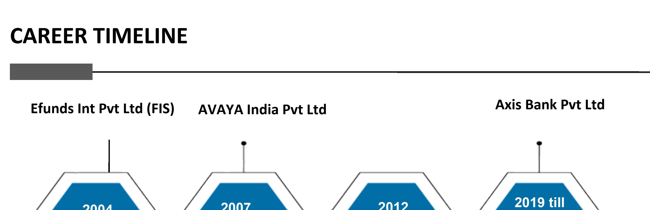
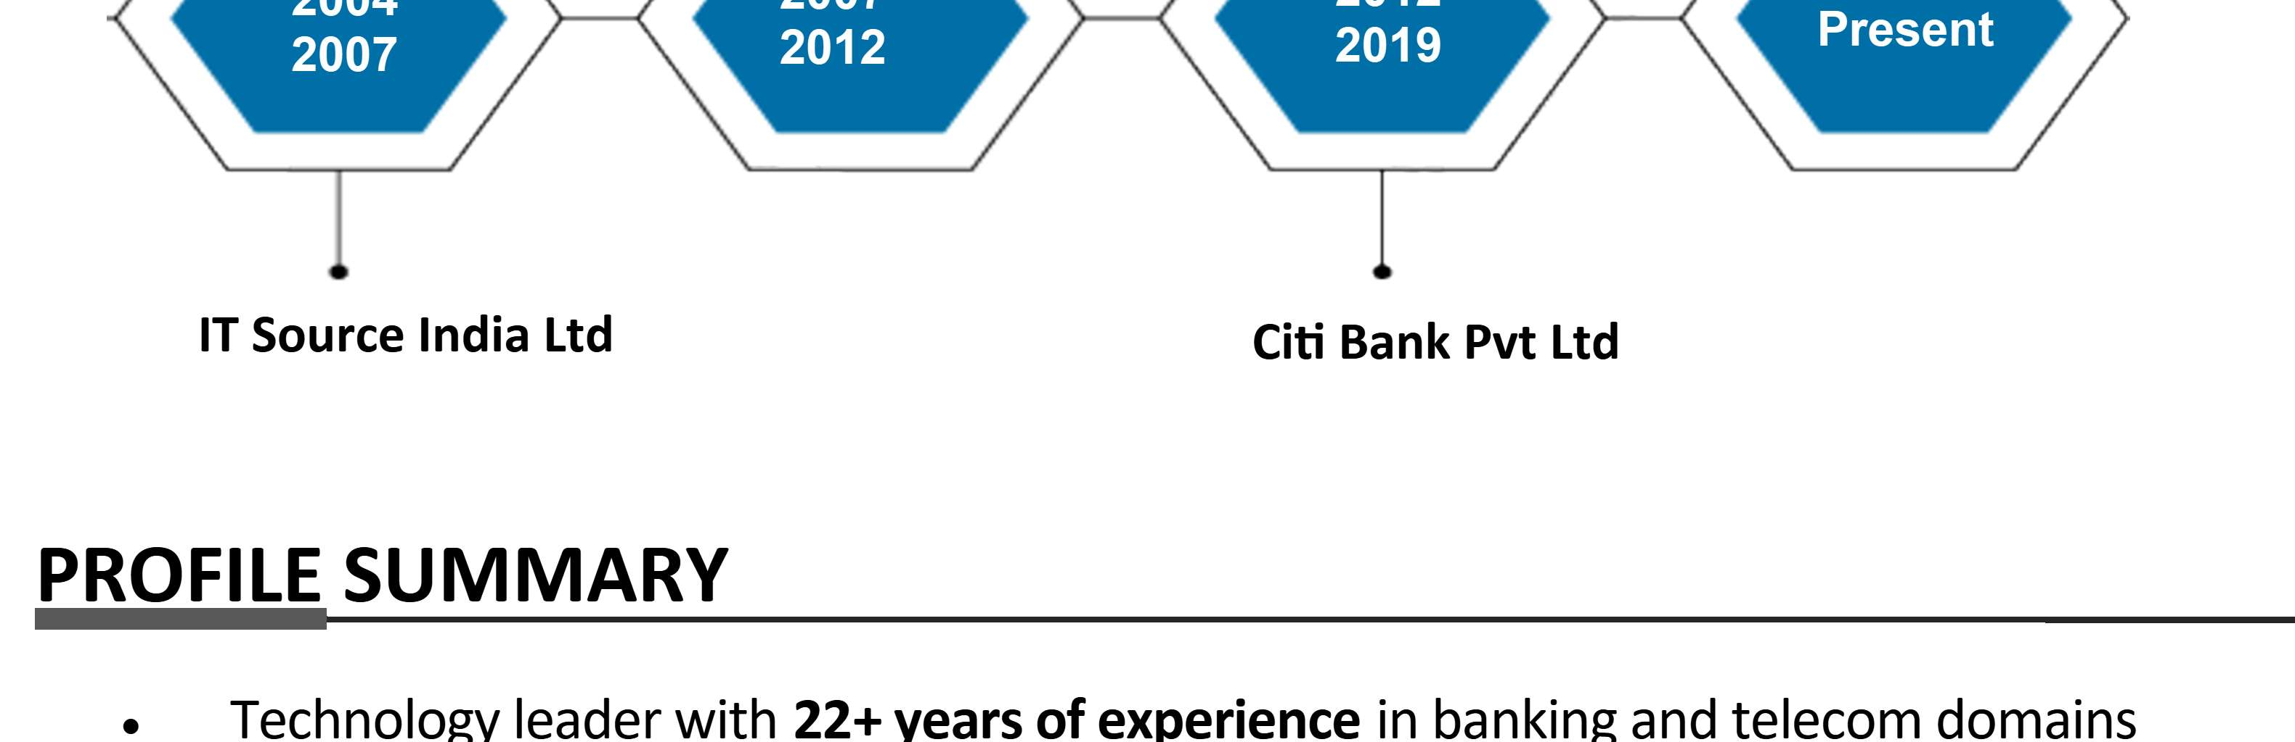
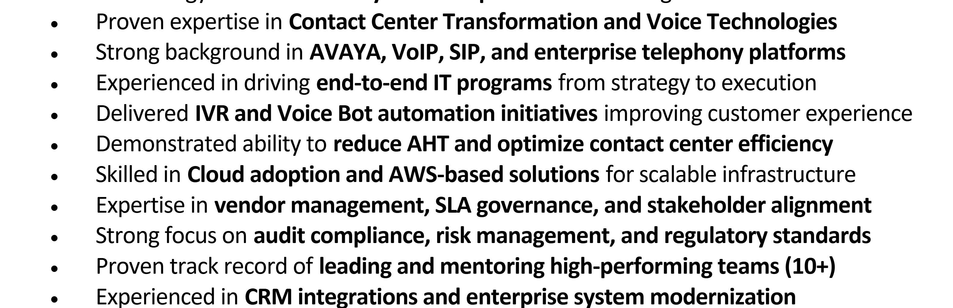
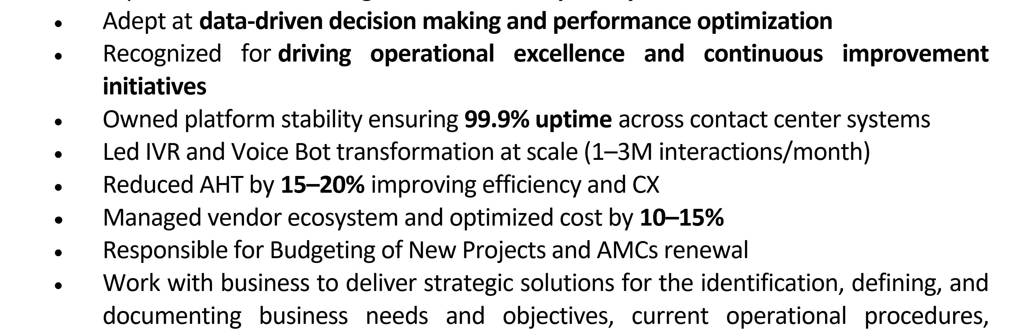
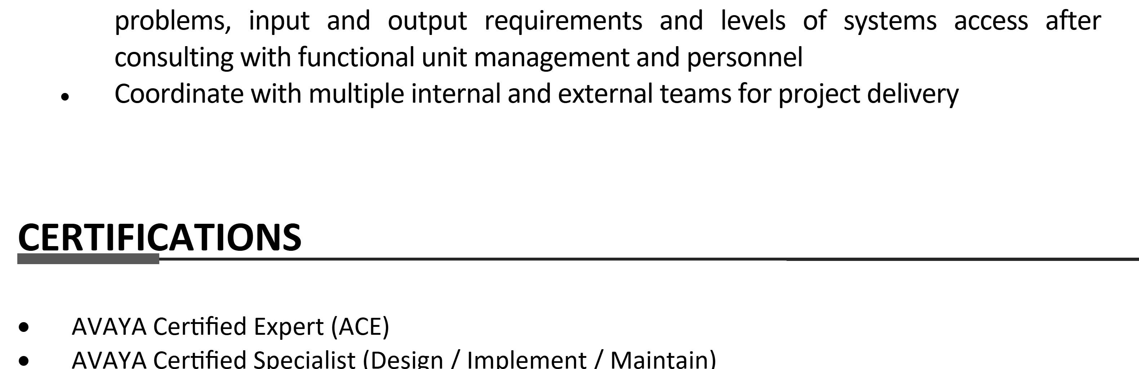
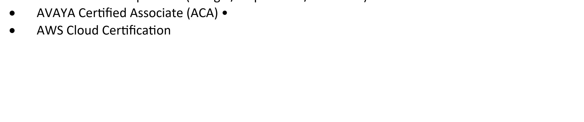
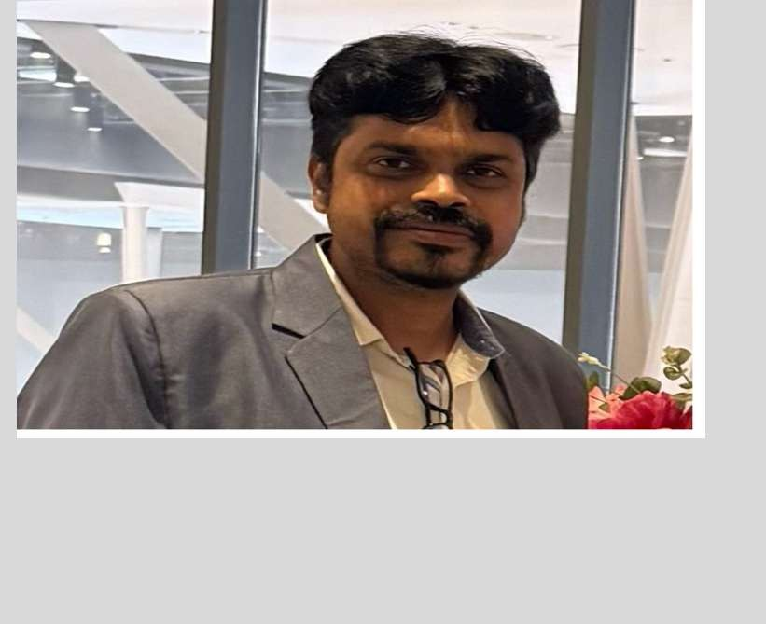




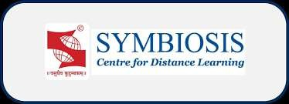
Experienced Financial and Business Analyst with 22+ years of expertise in generating data-driven insights, streamlining processes, and delivering high-impact results through strategic execution and stakeholder collaboration.
Sachin Jadhav
Assistance Vice President -Axis Bank

+91- 9930376902
sachinjad@gmail.com
Linkedin.com/in/sachinjadhav/

EDUCATION
- 2021-PGDBA (MBA) in Operations Management, Symbiosis Institute, Pune
- 2004 Bachelor of Engineering (Electronics & Telecommunication), Mumbai University

CORE COMPETENCIES
- Contact Center Transformation & Strategy
- Enterprise Voice Technologies (AVAYA, SIP, VoIP)
- Cloud & Digital Transformation (AWS, IVR Modernization)
- Customer Experience Optimization (CX, AHT Reduction)
- Program & Project Management (End-to-End Delivery)
- Automation & AI (Voice Bots, Call Steering)
- Vendor & Partner Management
- Stakeholder Management & Business Alignment
- Budgeting & Cost Optimization
- Audit, Risk & Regulatory Compliance
- CRM & System Integration (Enterprise Platforms)
- Operational Excellence & Process Improvement
- Incident Management & System Reliability (Uptime)
- Team Leadership & Talent Development
- Data-Driven Decision Making & Performance Metrics

TECHNICAL SKILLS

Languages & Database:
Oracle, SQL, Linux, Windows

Tools & Framework:
- Avaya CM, AES, CMS, Session Manager • IVR, ACD, Dialers, Verint, NICE • SIP, H.323, VoIP AWS Cloud (IVR hosting, scalable architecture) Cloud IVR, Voice Bots, Automation

WORK EXPERIENCE
Axis Bank India Ltd , Mumbai Mar 2019 to Present Duration: 7+ Year

Assistance Vice President -IT
Projects: Portfolio Management Contact Center for BFSI, Vendor Management, People Management.
Tech Stack: Voice Network, Data Network, IVR Bot, Call routing, Infra management

Significant Highlights:
- Leading and supervising teams, each having more than 4 financial/data analyst, developers and QA members.
- Lead Contact Center technology strategy and operations, managing large-scale transformation initiatives and BAU delivery.
- Drive end-to-end program management from scoping to deployment, including CRM integrations and IVR modernization.
- Deliver Voice Bot and Call Steering solutions, significantly improving customer experience and reducing AHT.
- Partner with business leaders to define strategy, identify gaps, and implement scalable technology solutions.
- Manage multi-vendor ecosystem, ensuring SLA adherence, delivery governance, and performance optimization.

Oversee budgeting, cost optimization, and AMC lifecycle management.
- Monitor and improve Cloud IVR performance metrics, ensuring high availability and efficiency.
- Lead and mentor a team of 10+ professionals, driving performance, capability building, and career growth.
- Ensure audit compliance, risk governance, and regulatory adherence across systems.

Citi Bank India Pvt. Ltd., Mumbai June 2012 to Mar 2019 Duration: 7 Years

Contact center Delivery Manager – Global Voice and IT Suport
Projects: Risk Model, Expansion, Movements of Contact center business, Upgrades and Enhancement. TechStack: AVAYA (S87XX, Session Manager,AES, CMS, Media Gateways) | NICE | NIM 4.1
VoIP | SIP | H.323 | H.245 | TCP/IP | ISDN | Contact Center Integration

Significant Highlights:
- Managed global contact center voice infrastructure, ensuring high availability, scalability, and performance across regions.
- Led L3/Tier-3 escalations for complex voice issues, driving resolution through a cross-functional ecosystem including vendors and internal teams (30+ members).
- Delivered multiple AVAYA IVR and ACD transformation projects, ensuring timely execution and adherence to project milestones.
- Acted as Solution Architect, designing and implementing enterprise-grade voice and contact center solutions.
- Owned capacity planning and uptime governance for critical voice systems, ensuring business continuity and reliability.
- Governed voice change management processes, including approvals and compliance with banking standards.
- Collaborated with integration and project teams to validate solution designs and ensure seamless deployment of new initiatives.
- Worked closely with service providers to troubleshoot and resolve trunk and network-related issues.
- Managed vendor relationships (AVAYA, NICE), ensuring delivery quality, timely escalations, and operational stability.
- Supported NICE platform BAU operations and contributed to continuous service improvements.
- Prepared and presented operational and performance reports to leadership for decision-making.

Tech Stack: C#,Avaya Aura(Session Manager,System Manager,SES) | Media Servers (S83xxâ€“S88xx) Media Gateways (G150â€“G700 series) | SBC | VoIP
| SIP | IP Telephony, Wireless (DECT, Polycom, Samsung) | Testing Tools (GERA, HAMMER, SVM)
Projects: Global customer support – Asia/EMEA and USA
Senior Telecom Engineer
Duration: 6 Years
Feb 2007 to June 2012
Avaya India Pvt Ltd , Mumbai

Significant Highlights:
- Senior Telecom Engineer | Feb 2007 -Jun 2012
- Provided global Tier-3 technical support for enterprise voice and SIP solutions across APAC, EMEA, and North America regions.
- Recognized as a Subject Matter Expert (SME) for Avaya platforms including media servers, gateways, and wireless voice solutions.
- Led troubleshooting of complex voice and SBC (Session Border Controller) issues, collaborating with Tier-4 and product engineering teams to resolve critical defects.
- Played a key role in deployment, configuration, and upgrades of large-scale Avaya environments (S83xxâ€“S88xx, Communication Manager, SES).
- Supported Avaya Aura suite including Session Manager, System Manager, and enterprise SIP architectures.
- Managed end-to-end lifecycle activities including implementation, upgrades, patching, and performance optimization.
- Provided support for converged communication systems (SIP, IP, digital, and analog telephony).
- Collaborated with global customers and business partners to resolve high-impact production issues and ensure service continuity.

Accomplishments:
- Acted as Process Champion for APAC, driving process standardization, quality improvements, and team capability building.
- Worked on wireless voice solutions (DECT, Samsung, Polycom) and enterprise collaboration systems.
- Utilized advanced testing and simulation tools (GERA, HAMMER, SVM) for issue replication and validation.
- Contributed to internal initiatives, including project management in Techathon events, demonstrating leadership beyond core operations.

Clients: MEA and USA
Sr. Engineer (Voice Solution and NWs)
Duration: 2 years
Jan 2005 to Jan 2007
Efunds Int Ltd (Allied Digital Ltd)
Projects – Banking and Insurance

Significant Highlights:
- Provided support for telecom solutions for Efunds International, managing centralized Customer Care Center operations in Mumbai and remote locations including Gurgaon, US, UK, and Chennai.
- Administered and maintained AVAYA DEFINITY Enterprise Communications Server and associated components across multiple sites.
- Handled maintenance and troubleshooting of MCC (Multi Carrier Cabinet) and EPN (Expansion Port Network), including cards such as SNI (Switch Node Interface) and EI (Expansion Interface).
- Performed system monitoring using IGX to ensure network stability and performance.
- Managed Witness Server for call recording and ensured uninterrupted recording services.
- Administered call center operations using CentreVu Call Management System (CMS) for reporting and analytics.
- Configured and managed CLAN cards and E1/T1 interfaces.
- Resolved CMS server-related issues and ensured high system availability.
- Maintained system downtime records, inventory, and server access credentials.
Projects – Voice NWs Clients – TCS
Engineer (Operation support)
Duration: 0.11 Years
Mar 2004 to Jan 2005
IT Source India Pvt Ltd

Significant Highlights:
- Managed maintenance and troubleshooting of AVAYA PBX systems including S8700 and G3R platforms.
- Worked with major clients such as Tata Consultancy Services (TCS), supporting VoIP (Voice over IP) infrastructure for TCSâ€“Air India environment.
- Served as Installation and Maintenance Engineer, responsible for deployment, configuration, and support of media gateways (G700) and IP telephony systems.
- Delivered end-to-end installation and configuration of IP Phones and ensured seamless integration with enterprise networks.
- Provided telecom solution support for ICICI Bank Ltd., managing centralized Customer Care Centers across Mumbai and Hyderabad.
- Ensured high system availability and quick resolution of telecom/network issues in mission-critical environments.

